Code:  
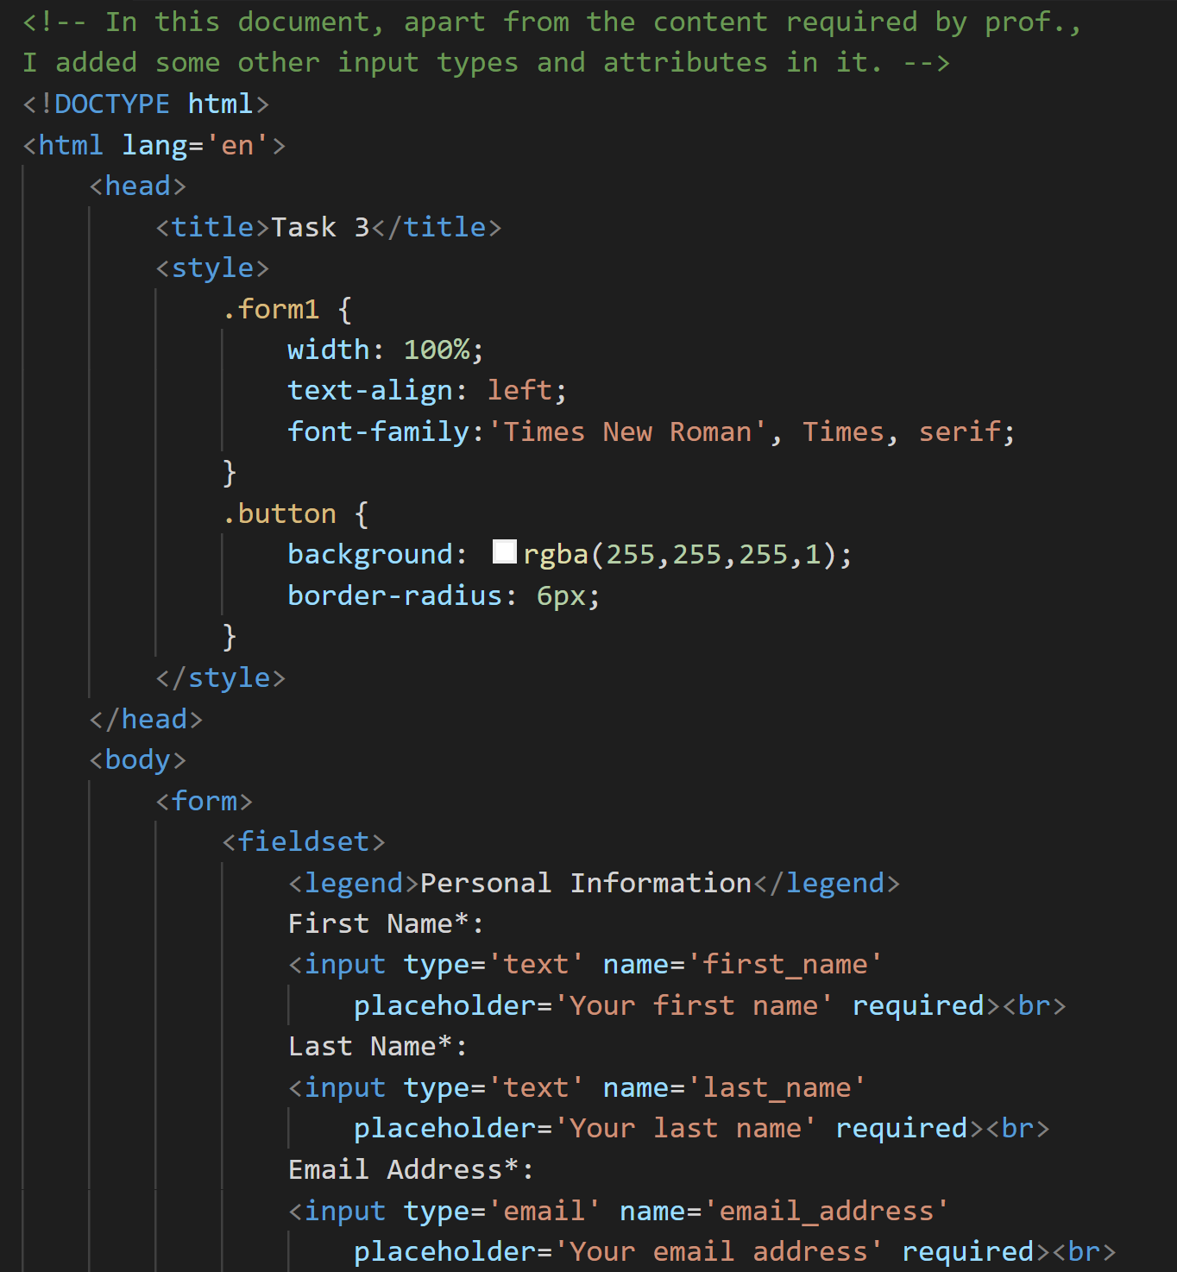  
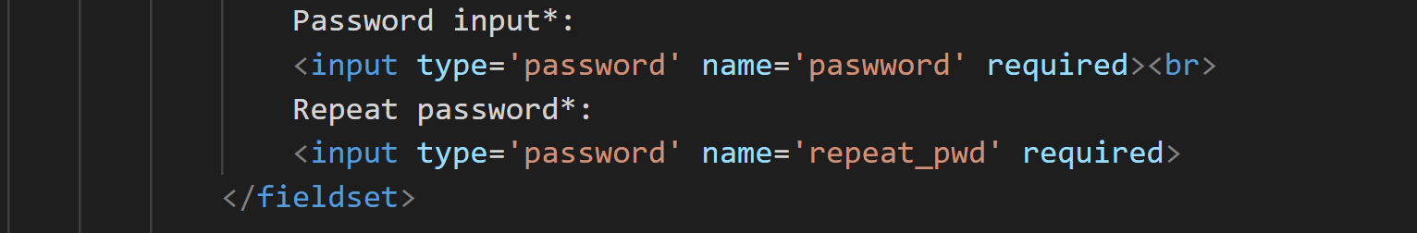

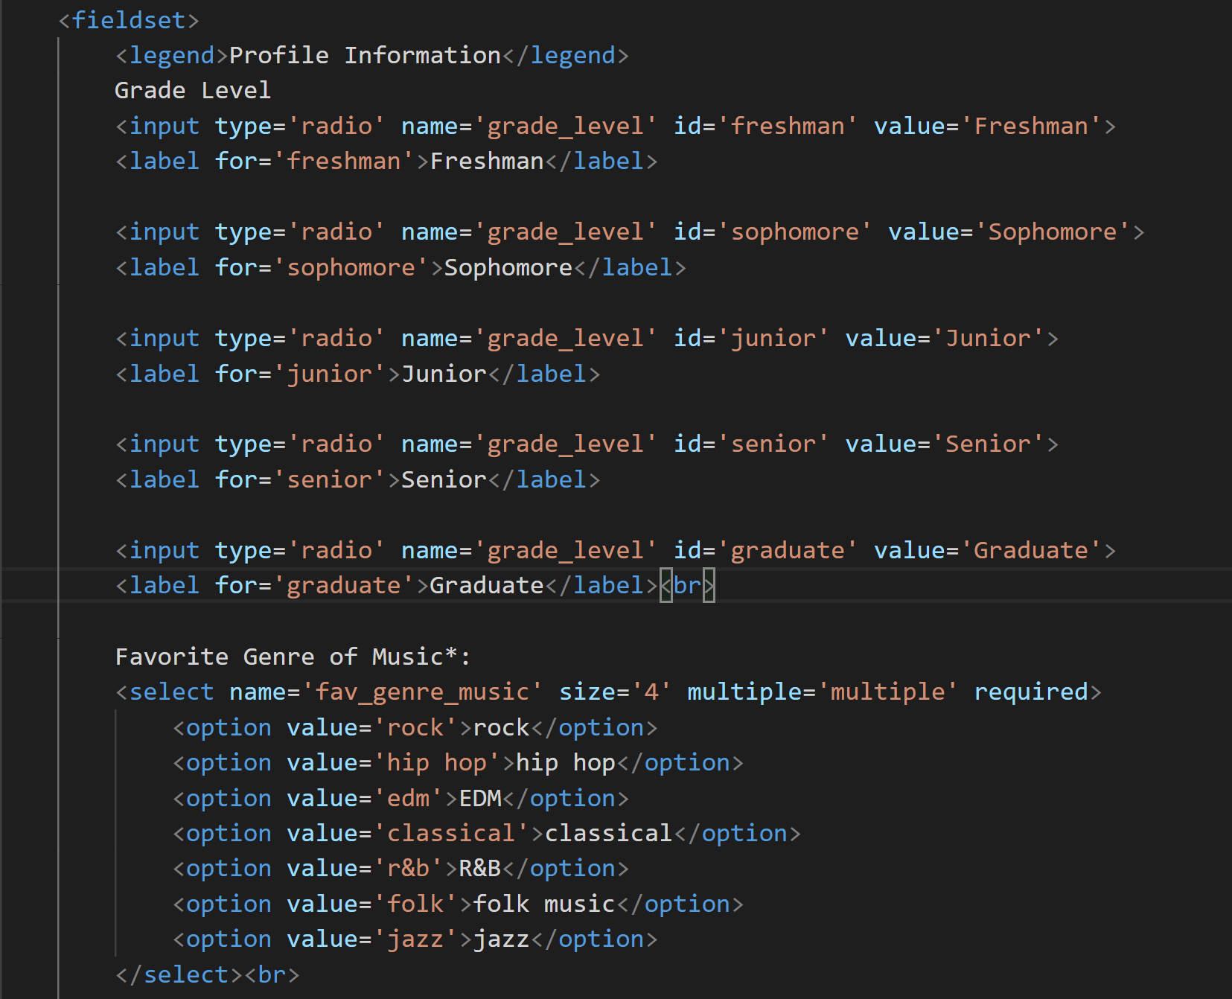  
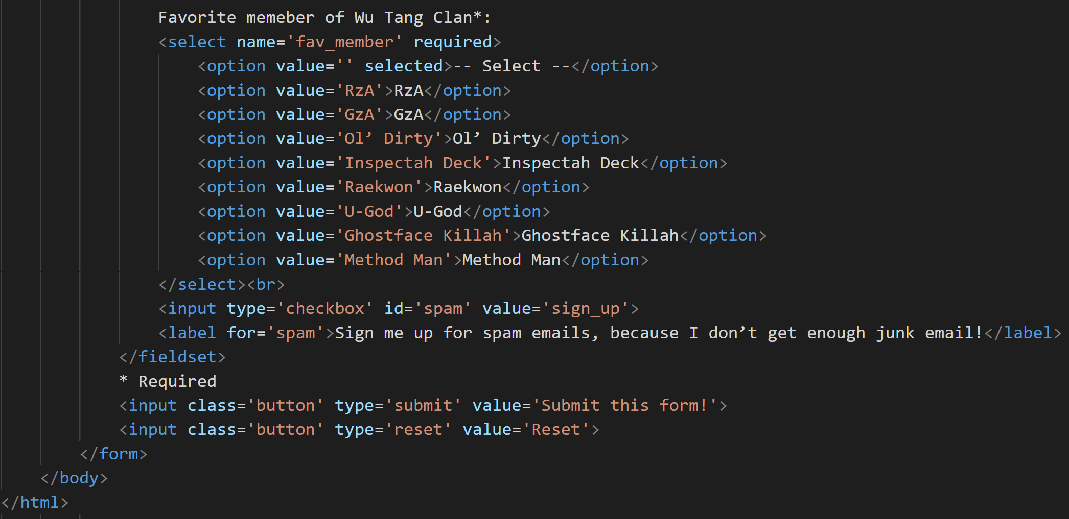  
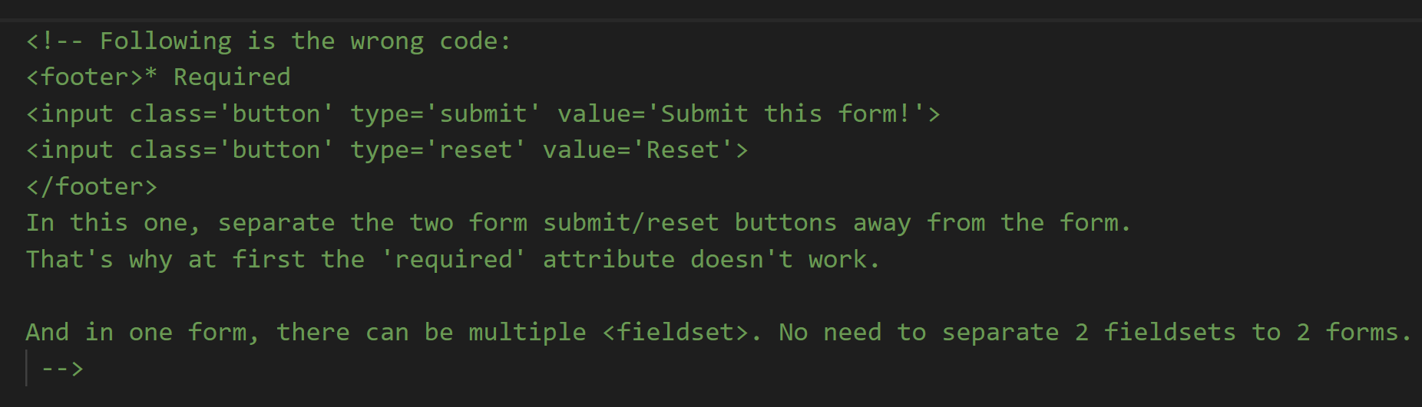

Form Elements:  
1.The <textarea></textarea> Element  
-The <textarea> element defines a multi-line input field (**a text area**)  
-<textarea> is **inline** element  
-**<input type="text"> defines a **one-line text input field**

<textarea name="message" rows="10" cols="30">  
The cat was playing in the garden.  
</textarea>  
-The rows attribute specifies the visible number of lines in a text area.  
-The cols attribute specifies the visible width of a text area.

You can also define the size of the text area by using CSS:  
<textarea name="message" style="width:200px; height:600px">  
The cat was playing in the garden.  
</textarea>

2. The <select></select> Element  
-The <select> element defines a **drop-down list**:  
<select name="cars">  
  <option value="volvo">Volvo</option>  
  <option value="saab">Saab</option>  
  <option value="fiat">Fiat</option>  
  <option value="audi">Audi</option>  
</select>  
- value="volvo" this is the real value sent to the server, the word contained in <option> and </option> is only displayed to users.  
-The <option> elements defines an option that can be selected. By default, the first item in the drop-down list is selected. To define a pre-selected option, add the selected attribute to the option

-Use the size attribute to specify the number of visible values:  
<select name="cars" **size="3"**>  
  <option value="volvo">Volvo</option>…  
-Use the multiple attribute to allow the user to select more than one value.

3. The <button></button> Element   
-The <button> element defines a clickable **button**:  
<button type="button" onclick="alert('Hello World!')">Click Me!</button>  
- Note**:** Always specify the **type** attribute for the button element. Different browsers may use different default types for the button element.  
-**<input type=’submit’ value=’Voila’> 🡪 In this <input> element, value of the attribute “value” will be the content of this button, displayed on screen, while in <button> element, the content of the button displayed on screen has to be written between <button> and </button>, so <button> is a container.

4. HTML5 <datalist></datalist> Element  
-The <datalist> element specifies a list of pre-defined options for an <input>element.  
-Users will see a drop-down list of the pre-defined options as they input data.  
-The list attribute of the <input> element, must refer to the id attribute of the <datalist> element.  
<form action="/action_page.php">  
  <input list="browsers">  
  <datalist id="browsers">  
    <option value="Internet Explorer">  
    <option value="Firefox">  
    <option value="Chrome">  
    <option value="Opera">  
    <option value="Safari">  
  </datalist>   
</form>

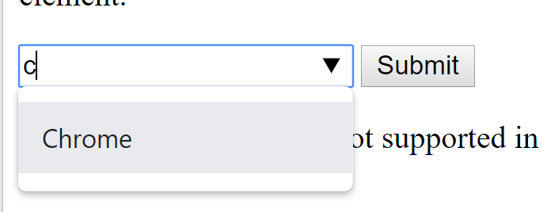

-Here, without <type=…> and only <input>, the default type of <input> element is “text”, so a box allowing text input is displayed.  
-And <option> without closing tag </option>

5. HTML <optgroup></optgroup> Tag  
-The <optgroup> is used to group related options in a drop-down list. If you have a long list of options, groups of related options are easier to handle for a user.  
-<optgroup> is a container.  
<select>  
  <optgroup label="Swedish Cars">  
    <option value="volvo">Volvo</option>  
    <option value="saab">Saab</option>  
  </optgroup>  
  <optgroup label="German Cars">  
    <option value="mercedes">Mercedes</option>  
    <option value="audi">Audi</option>  
  </optgroup>  
</select>

